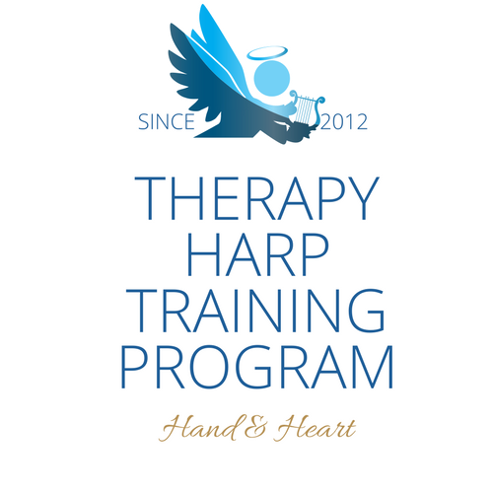

THTP INTERNATIONAL HARP RETREAT
Emiemi Aroha Nui

New Zealand 2019: Friday 18th to Sunday 20th January

THANK YOU FOR COMING! It’s going to be a very special event, to help me organise everything for you I would appreciate you filling in this form, please email it to:
marion@therapyharp.com

If you are ALSO attending the QVM training on Monday 21st January please indicate that below and fill in the Quantum Vibro Massage Application form as well which will be available shortly on the QVM website

PLEASE USE CAPITAL LETTERS or type!!

Name/s:

Full address with postcode:

Home tel: Mobile tel:

Email:

Harp teacher/inspirational supporter?:

Length of harp/flute/voice/guitar study:
Harp size/flute type normally played:

Do you need to borrow anything? (cost to hire a harp is $ 40 )

Any other instruments that you play and/or are bringing?

Date/ Place and Time of arrival into NZ?
(please attach flight details if you are booking transfer from airport via me)

Accommodation requirements?:
Dietary requirements/Allergies:

PAYMENT
Retreat Fee | International attendees  $250 US/AU/EU | NZ Residents  $99 NZ | Cost to book
Accommodation | Included | Not included | $40 per night
Transfer from Auckland Airport | Included | Not included | $150pp
Friday eve meal | Included | Not included | $15
Saturday Breakfast | Included | Not included | $10 Cooked
Saturday lunch | Included | Included | Included
Saturday evening meal | Included | Included | Included
Sunday breakfast | Included | Not included | $10 Cooked
Sunday lunch | Included | Included | Included
Sunday evening | Included | Included | Pot Luck
Transportation to all locations during Retreat ie Recording studio/Park/City | Included | Not included | $20
Recording studio session | Included | Included
Harp Hire | Included | Not included | $40
QVM 1 day Training | Included | Not included | $99

So that I can book transport/facilities please can you send me the deposit by November 30th 2018
Deposit $100 (non-refundable)

So that I can make final arrangements around food etc please pay the final instalments by January 1st 2019.

Please add up your own Full Fee depending on what you opt to do.

Accommodation for NZ attendees MUST be discussed with the Retreat organiser so that I can arrange the perfect accommodation for you!
Camping in tents is FREE! But sorry there is NO room/access for a House bus.

Full fee $

I do / do not need to hire a harp
.
I enclose $ for harp hire (non-refundable), please pay at time of deposit.

I DO/DO NOT want to book a place at the QVM 1 day training.

Please make payment to Marion Titmuss
By either Bank transfer (NZ Residents)
BNZ 02 0655 0080160 67 or Paypal (International)
Using marion@kingsmusic.co.nz

Signed: Date:

